**Stock Price Analysis Dashboard with Plotly Dash**

**Description:**

In this folder you can find the following files:

1. The source code: Predictor_Jupyter.ipynb
2. Three model files: LSTM_BTC_model.h5, LSTM_NASDAQ_model.h5, LSTM_SNP500_model.h5

The purpose of this application is to build an interactive dashboard using the Plotly Dash framework that will chow the historical price of the specific stock and a graph with the predicted price of that stock that was predicted using a LSTM algorithm.

The dashboard consists of three tabs one for each stock: Bitcoin, NASDAQ and SNP500.

**Installation of packages needed for running the application**:

* Python v3.10
* Numpy
* Pandas
* Matplotlib and rcParms
* Json and requests
* Keras.models
* Keras.layers
* Sklearn
* Dash
* Dash_core_components
* Dash_html_components
* Dash.dependencies

**User Interface:**

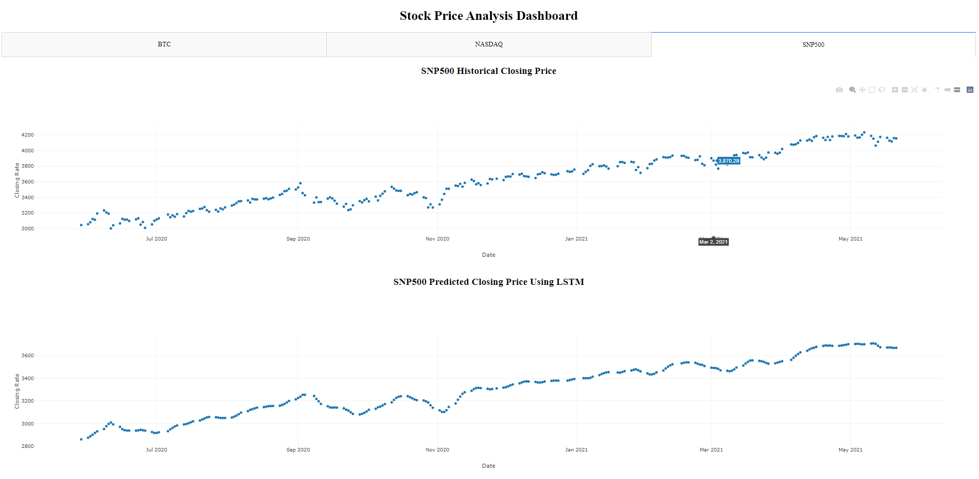

There are three tabs for each of the stocks. For each of the tabs inside there are two graphs, the one on top shows the historical closing prices and the one bellow shows the predicted closing price using LSTM.

**Usage and features**

Using the dashboard is simple and easy, switching between the tabs is done by clicking on the tab names. Then in order to see more details about the historical closing prices one can hover over the graphs desired position with the mouse.

**Ways to improve**

This is the first version of the dashboard and it can be improved in different ways:

1. The User Interface can be improved to be more pleasant for the user;
2. More tabs with more stocks can be added;
3. More graphs can be created for more details regarding the stocks
4. Improve the precision of the predictions done by the algorithm